
Final Examination
NE 0407300
Fall 2024-2025

- You have 120 minutes to complete the solution of the questions below.
- Be sure you put your name and UOS ID #.
- Write neatly and clearly.
- Illegible responses will not be graded.
- Divide your time carefully between the questions.
- Academic dishonesty will result in a zero mark for the midterm exam and potential F in the course.
- Justify your assumptions and answers scientifically. Show detailed steps of your calculations.
- Use 4 significant digits in your answers whenever suitable.

Name: ID:

Question | Q1 | Q2 | Q3 | Q4 | Q5 | Q6 | Total
Score | /10 | /20 | /20 | /20 | /10 | /20 | /(100)

Q1) A material has been discovered with a total thermal neutron cross section of 1200 barns, a neutron capture cross section of 250 barns, and a neutron scattering cross section 27 barns. Based on the information given, is it possible that this is a fissile material and what is the probability of fission interaction? [10%]

Answer:
$$σ_{t}=1200 b$$
$$σ_{γ}=250 b$$
$$σ_{s}=27 b$$
$σ_{f}=σ_{t}-σ_{γ}-σ_{s}=923 b$ Most likely fissile since the fission probability is 76.92%

Q2) Suppose that a fissile material is discovered for which all the neutrons are prompt. Furthermore,
suppose that a reactor fueled with this material has a prompt neutron lifetime of 0.002 s. [20%]

- If the reactor is initially critical, and there is no source present, what period should the reactor be put on if it is to double its power in ten seconds [10%]?

Answer:
$$n\left(t\right)=n\left(0\right)\exp\left(\frac{k-1}{l}t\right)=n\left(0\right)\exp\left(\frac{t}{T}\right), T=\frac{l}{k-1}$$
$$T=\frac{t}{\ln\left(\frac{n\left(t\right)}{n\left(0\right)}\right)}=\frac{10}{\ln{2}}=14.4260 s$$

- What is the value of the multiplication factor ($k$) in this case [10%]?

Answer:

$$T=\frac{l}{k-1}→k=1+\frac{l}{T}=1+\frac{0.002}{14.426}=1.000139$$

Q3) Given the Data below answer questions A and B [20%]:

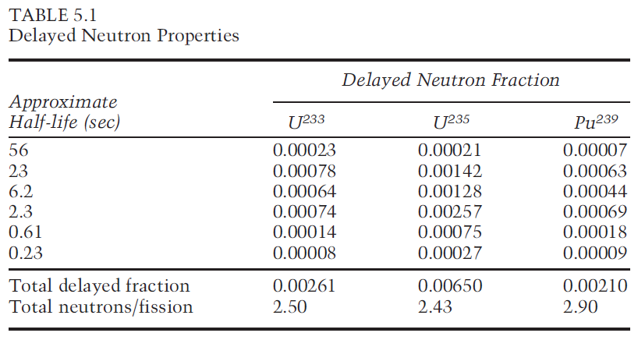

- A power reactor is fueled with slightly enriched uranium. At the middle of core life 10% of the power comes from the fission of the built-up plutonium-239. Calculate the effective value of $β$ at the beginning and at the end of core life; determine the percent increase or decrease [10%].

Answer:
$β_{eff}$ at BOC is $β_{eff}^{25}=0.0065$
$β_{eff}$ at EOC is $β_{eff}=0.9×β_{}^{25}+0.1×β_{}^{49}=0.00606$

- Calculate the reactivity (in units of $ and $¢$) of the reactor above (initially critical) if its multiplication factor suddenly becomes $k=1.005$. [10%]

Answer:
$$ρ=\frac{k-1}{k}=0.00497{∆k}/k=497 pcm$$
$$ρ\left(\$\right)=\frac{ρ}{β}=\frac{0.00497}{0.00606}=0.82\$=82 ¢$$

Q4) Long term core behavior [20%]

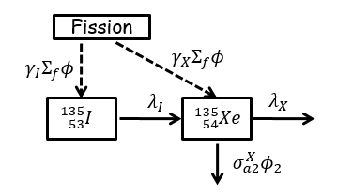
- Write down the balance equation(s) for Xe-135 [10%]

Answer:
$$\frac{dI}{dt}=γ_{I}Σ_{fT}ϕ_{T}-λ_{I}I$$
$$\frac{dX}{dt}=γ_{X}Σ_{fT}ϕ_{T}+λ_{I}I-λ_{X}X-σ_{aT}^{X}ϕ_{T}X$$

- Derive an expression for the steady state concentration of Xe-135 and I-135 based on the above-mentioned schemes? [10%]

Answer:
At equilibrium state $\frac{dI}{dt}=\frac{dX}{dt}=0$
$$I_{∞}=\frac{γ_{I}Σ_{fT}ϕ_{T}}{λ_{I}}$$
$$X_{∞}=\frac{λ_{I}I_{∞}+γ_{X}Σ_{fT}ϕ_{T}}{λ_{X}+σ_{aT}^{X}ϕ_{T}}=\frac{\left(γ_{I}+γ_{X}\right)Σ_{fT}ϕ_{T}}{λ_{X}+σ_{aT}^{X}ϕ_{T}}$$

Q5) Reactivity & Control [10%]:

- The moderator temperature coefficient for a reactor is -12 pcm/ °F. Calculate the reactivity defect that results from a temperature decrease of 10°F. [5%]

Answer:
$$∆ρ=α_{M}ΔT=-12\frac{pcm}{℉}×-10℉=120 pcm$$

- Plot approximate figures (with relative units) showing the differential and integral rod worth as a function of the insertion depth in the core (y-axis: the rod worth, x-axis: fraction distance from bottom of the core )? [5%]
Answer:
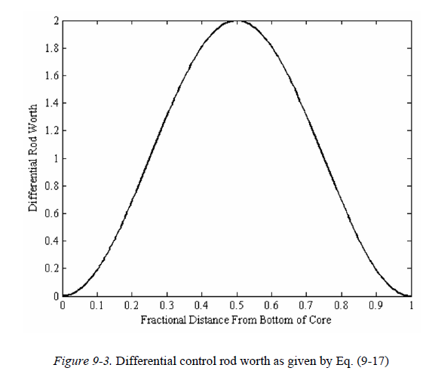
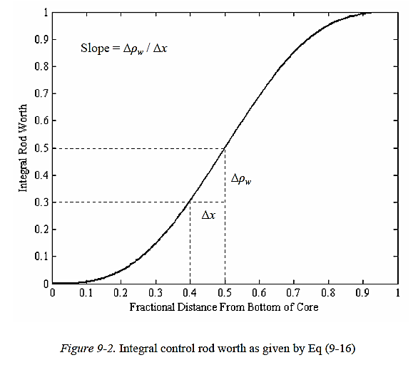

Q6) Consider a thermal reactor with the 6 factors’ values below [20%]:
$ε=1.04$, $η=2.01$, $p=0.81$, $f=0.751$, $P_{NL}^{f}=0.89$, $P_{NL}^{th}=0.90$

- Estimate the multiplication factor of this reactor ? [10%]

Answer:
$$k=1.01856$$

- If the non-fuel thermal neutron absorption cross section increase by 10% in total, which factor will be affected by this change and what would be the updated value of the multiplication factor? [10%]

Answer:

The thermal utilization will be affected by this change:
$$f^{'}=\frac{f}{1.1}=0.6827$$
$$k^{'}=\frac{k}{\begin{aligned}1.1 \\ \end{aligned}}=0.9259$$

